Preprocessing and analysis of Affymetrix microarray data for library pooled shRNAs

Dchip preprocessing of Affymetrix microarrays:

1. Create a folder containing cel files (eg GreatExpt_cel_files)
2. Create a folder to hold dcp (dchip) files (eg GreatExpt _analysis_yyddmm)
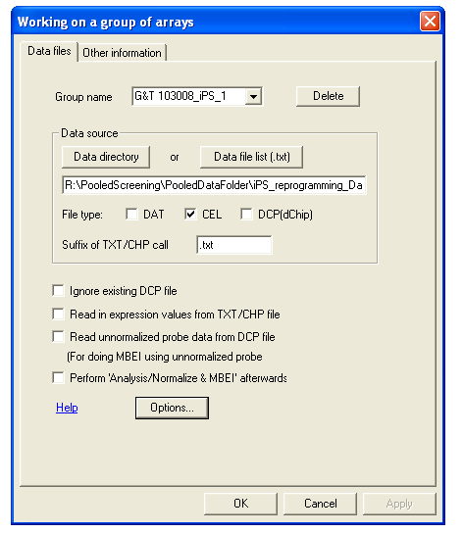
3. Open dchip (dchip2006_f5_070502.exe)
4. Under Analysis, select “Open group”

5. Name a new group if starting a new data set

6. Under Data source, click on Data directory, browse to the folder containing the cel files.

7. Make sure the CEL is selected if cel files are analyzed

8. Click on Options button near the bottom (Options can be selected and changed at any time)

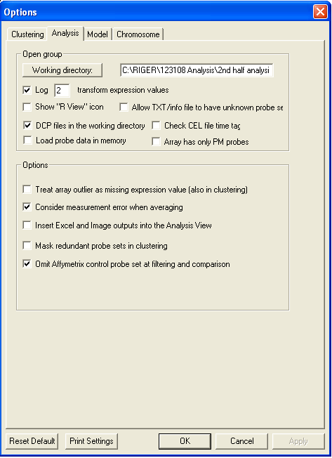
9. Click on Analysis option (at the top)

10. Click on Working directory to locate folder created in step 2 above (GreatExpt _analysis_yyddmm)

11. Select Log2 transform expression values

12. Select DCP files in the working directory
Deselect Check CEL file time tag
Deselect Load probe data in memory
Deselect Array has only PM probes

13. Select Consider measurement error when averaging
14. Select Omit Affymetrix control probe set at filtering and comparison

15. Click Model option (at the top)

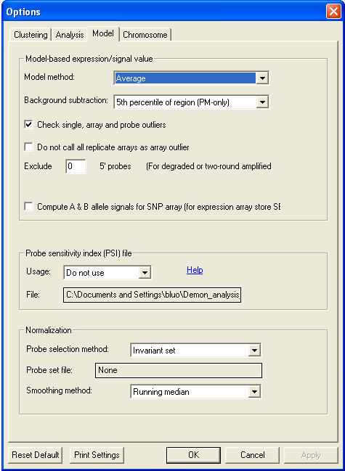

16. For Model method, start with Average

17. For Background subtraction, start with using 5th percentile of region (PM-only)

18. Select Check single, array and probe outliers

19. For Probe sensitivity index (PSI) file, Choose Do not use for Usage

20. Under Normalization, choose Invariant set for Probe selection method; keep None for Probe set file; choose Running median for Smoothing method

21. Click OK to finish Options selections

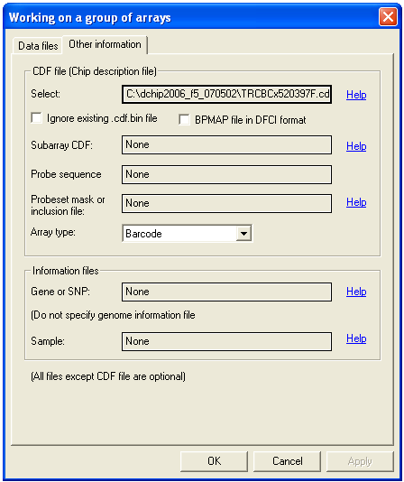

22. Click on Other information (at the top)

23. Under CDF file, click the button after Select.
Locate the CDF file (TRCBCx520397F.cdf)
This is specific for the array you use

24. For Array type, select Barcode (last option)

25. Click OK to start preprocessing

Dchip log file will show something similar to depending on your file names and paths and number of arrays in analysis:

Converting CDF file 'C:\Documents and Settings\bluo\Demon_Dchip_071101\TRCBCx520397F.cdf' into dChip binary format for faster access...
Line 2890000
Saving C:\Documents and Settings\bluo\Demon_Dchip_071101\TRCBCx520397F.cdf.bin ...

Search and extract PM/MM data from 'CEL' files of chip type 'TRCBCx520397F' in
C:\Documents and Settings\bluo\Demon_Dchip_071101\Demon071101_cel_files...

Found C:\Documents and Settings\bluo\Demon_Dchip_071101\Demon071101_cel_files\D_061129_97.CEL
Reading CEL file...
Not a text format CEL file, use binary reading
Row 700
Cannot find Affymetrix analysis call file 'C:\Documents and Settings\bluo\Demon_Dchip_071101\Demon071101_cel_files\D_061129_97.txt'
No matching TXT file; calculating Presence calls...
Gene 125700: P
………
……….

Writing array summary file C:\Documents and Settings\bluo\Demon_Dchip_071101\Demon_analysis_071101\Demon_071101 arrays.xls

Group "Demon_071101" contains 12 arrays; see 'C:\Documents and Settings\bluo\Demon_Dchip_071101\Demon_analysis_071101\Demon_071101 arrays.xls' for details

Treat all the 12 arrays as 12 samples and 1 sample groups

Finished in 00 hours 00 minutes 55 seconds}

26. Under Analysis, choose Normalize and Model

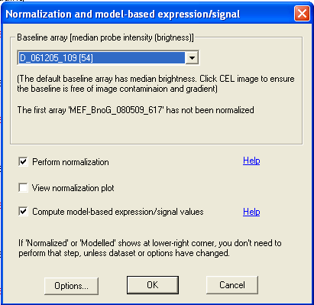
27. Choose a Baseline array (for dataset including DNA sample, I have been using D-061205_109 (45K library); for dataset containing drug treatment, use one of untreated sample as Baseline array)

28. Select Perform Normalization
29. View normalization plot is optional: selection of this option will slow down the analysis if many arrays are being analyzed
30. Select Compute model-based expression/signal values

31. Options (at the lower left corner) can be accessed to change the options for normalization and model-based calculations

32. Click OK after reviewing normalization plots

Example of normalization plot option (29 above)
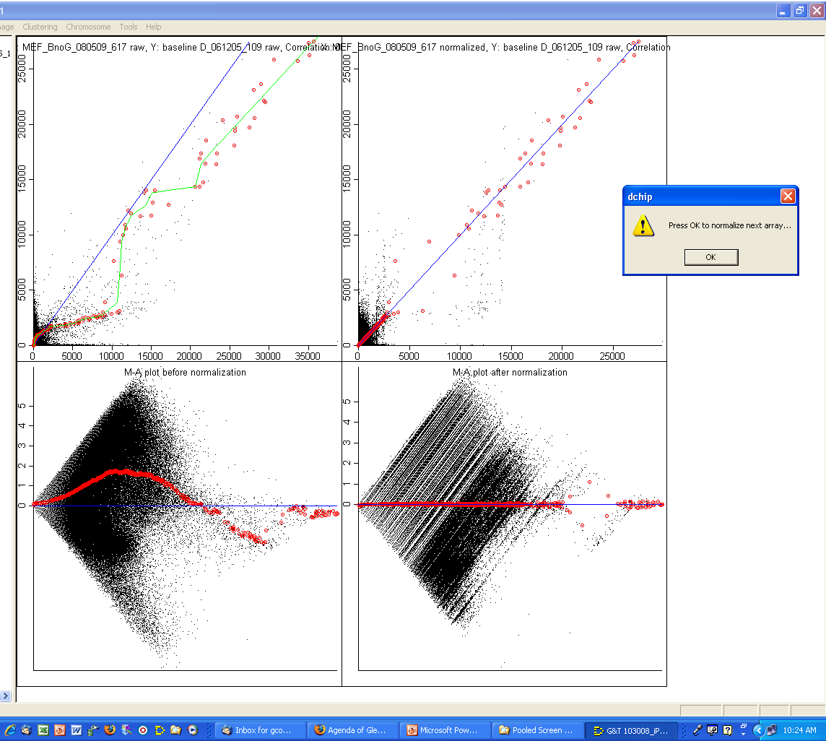
Dchip log file will show something similar to depending on your file names and paths and number of arrays in analysis:

{Normalize arrays using probes of 'Invariant set' and 'Running median' smoothing
Read in existing binary CDF file C:\Documents and Settings\bluo\Demon_Dchip_071101\TRCBCx520397F.cdf.bin (file format 5)...

Baseline array: D_061205_109
Accessing 'D_061205_109.dcp' (file format 5)
Median probe intensity: 54

View normalization plots for details...
D_061129_97
Accessing 'D_061129_97.dcp' (file format 5)
Searching Invariant-set: 5571
Median probe intensity: 71 -> 55
Making plots...
Scatter plot of PM and MM data before normalization...
Scatter plot of PM and MM data after normalization...
M-A plot before normalization...
M-A plot after normalization...
……..
Finished in 00 hours 04 minutes 12 seconds}
{Model-based expression

Read in existing binary CDF file C:\Documents and Settings\bluo\Demon_Dchip_071101\TRCBCx520397F.cdf.bin (file format 5)...

Obtain model-based expression values using 'Average' method and '5th percentile of region (PM-only)' as background
Load probe data for probe set 0 to 125942 from DCP files...
Array K_3D_070413_330
Probe set 125943

Saving expression values into dChip(DCP) files...
Accessing 'D_061129_97.dcp' (file format 5)
Accessing 'D_061129_98.dcp' (file format 5)
……
Log 2 transforming the expression values (< 1 values truncated to 1 first)...

Writing array summary file C:\Documents and Settings\bluo\Demon_Dchip_071101\Demon_analysis_071101\Demon_071101 arrays.xls

Finished in 00 hours 01 minutes 09 seconds}

At this point, preprocessed data can be exported:
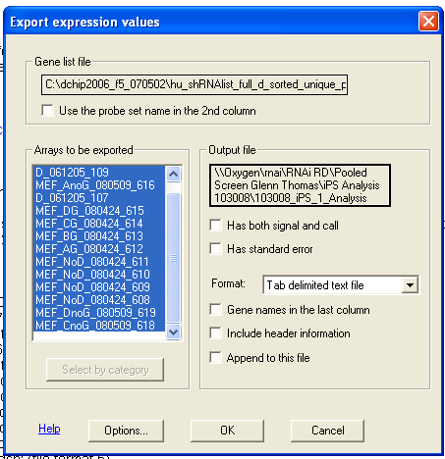
33. Under Tools, choose Export expression values

34. Under Gene list file, locate the file: hu_shRNAlist_full_d_sorted_unique_present_shrna.txt
for the human 45k library.
TSMTOtotal080402f_annot.txt for the human 55K library
This is specific for the array you use
The gene list file should contain probe sets in txt that is formatted in PC (the file formatted in Mac doesn’t work)

35. Choose all the arrays in Arrays to be exported window

36. Click on the Output file button to locate to the destination folder and name the file
If RIGER is to be used next give file following format:
Path\filename.gct

37. Click on Options button (lower left)
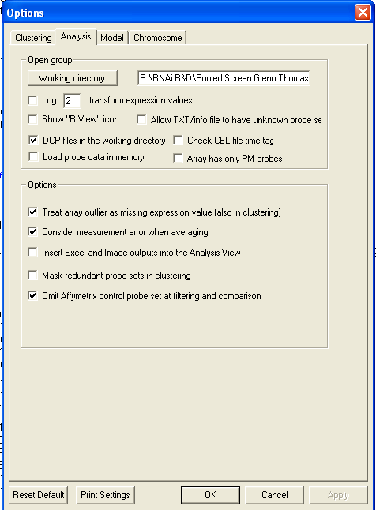

38. Deselect Log2 transform expression values if the data is already Log2 transformed

39. Click OK to start

Dchip log file will show something similar to depending on your file names and paths and number of arrays in analysis:

{Export expression values

Writing expression or call data in C:\Documents and Settings\bluo\Demon_Dchip_071101\Demon_analysis_071101\Demon_071101expression.xls...
Export the data for genes in file C:\Documents and Settings\bluo\Demon_Dchip_071101\hu_shRNAlist_full_d_sorted_unique_present_shrna.txt
Probe set 45182 (# is 54020 for 55K library pool)
Finished}

From here either 2 class comparisons within dCHIP , or RIGER analysis can be performed. See below for Instruction for each process.
RIGER Analysis: (see http://broad.mit.edu/cancer/software/rnai/riger/ for extra help)

The .GCT file created above (step 36) can be used with slight modification for RIGER.
Necessary modification of the GCT file:

1. Open GCT file with excel
2. Insert 1 column between column A and B
3. Insert 2 rows at the top of the file
4. In cell A1 type “#1.2” {This in a notation required by RIGER}
5. In cell B1 enter the total number of hairpins screened
For 45K library pool enter 45182
For 55K library pool enter 54020
6. In cell B2 enter the total number of samples in analysis
{This is the total number of columns in GCT file - 2}
7. Save file in same format {do not change to excel worksheet}

After starting RIGER and loading your GCT file you should see a heat map and be prompted for 2 annotation files:

Chip file: Use TRC.CHIP for 45K library library pool
Use TRChuV2.CHIP of 55K library library pool

Sample INfo File: This excel file is customized according to your sample set.
Column A is headed with “sample” and has a list of the original Affy Chip files used
Column B onwards can be customized to cluster samples into categories that may help in grouping samples during future comparisons. See “Sample sin file”

NOTE: These files can be loaded within RIGER using:
File/Categorize Samples/ choose your custom SIN file
File/Annotate Hairpins/ choose “TSMTOtotal080402f_annot” file and select desired annotation columns
Dchip to perform two-class comparison:
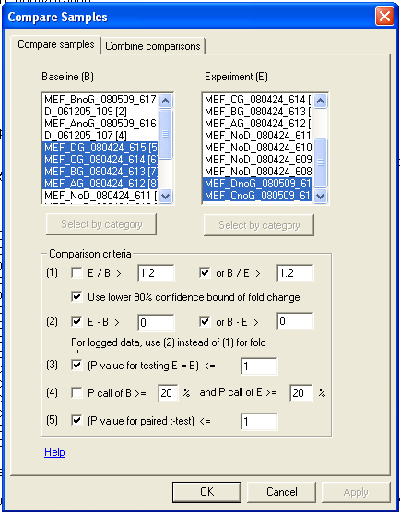
1. Under Analysis, choose Compare Samples

2. Choose Baseline arrays from left window
3. Choose Experiment arrays from right window

Under Comparison criteria (considering the data are Log2 transformed, the difference of Log2 transformed data is similar to the ratio of untransformed data),
4. Deselect (1) E/B;
5. Select (2) E-B, but change the value E-B>0 to output all data;
6. Select (3) (P value for testing E=B), change the value (P value for testing E=B)<= 1 to be inclusive
7. Deselect (4)
8. Select (5) (P value for paried t-test) if it is available, but change the value to 1 to be inclusive

9. Click Combine comparisons (at the top)

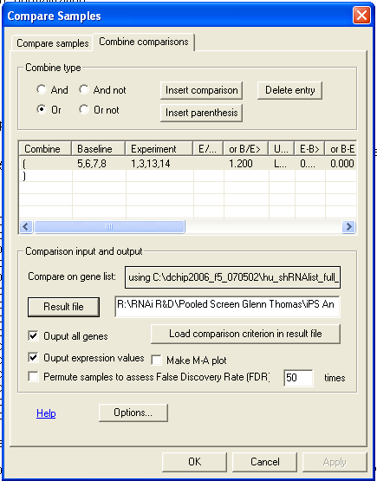

10. Under Comparison input and output, click on Compare on gene list button to locate the file hu_shRNAlist_full_d_sorted_unique_present_shrna.txt for the human 45k library

11. Click on Result file button to locate the destination folder and name the file

12. Select Output all genes

13. Select Output expression values

14. Click on Options button in lower left to make sure the Log2 transform expression value is Deselected if the data are already Log2 transformed

Expression values, averages of the groups, differences between the two groups, P value and T-test value will be included in to comparison results
Reopen the data set in Dchip: if the dcp files are not removed for the dataset, use Open group and locate the group corresponding to the dataset next time in Dchip. Alternatively, under Analysis, choose Get External Data, click on Data file, locate the exported file containing the dataset.

Analysis of exported data in Excel:

Open Comparison result file
Open Annotation.xls (hu_shRNAlist_full_d_sorted_unique_present_shrna.txt has some merged cells to prevent sorting)
Copy the detailed hairpin information to the result file
Make a copy of the annotated result worksheet
Sort by difference, P-value, t-test or combination of them
Choose a cutoff (e.g. top 2000, 1000, 400)
Remove the data below the cutoff
Highlight source ID (NM numbers) to shRNA
Under Data, choose PivotTable Report
Click Next
Click Next
Click Layout
Place symbol to ROW
Place symbol into DATA
Keep “Count of symbol”
Click OK
Click Finish
Click any number below Total
Under Data, choose Sort
Change to Descending
Place sourceId (NM numbers) to the right of symbol in PivotTable
Place desciption next to sourceId
Change View to Normal
Change magnification to 75% to fit inside the window
Place shRNA next to description
Click the redundant description, under Edit, choose Hide
Hide the redundant NM numbers
Scan for closely overlapping shRNAs to remove the false multiple hairpin hits, because the their similarities in off-target activity and cross-hybridization

